**Task 9: Extended Response**

Comparison of Electric and Traditional Cars VALIDATION

**SOLUTIONS**

Name: ­­_______________  
Teacher: ______________

Mark: ­­­­___/25  
Comment: __________________ _____________________________________________________________________________

**Assessment type:** Extended Response

**Conditions**

3 periods of research

1 period of validation-Monday 26th of July

**Task weighting**

10% of the school mark for this pair of units

6% for Assignment

4% for Validation

Below are 3 questions about **conventional vehicles.**

1. a) What primary reaction causes convention cars to move?

_Combustion___________________________________________(1 mark)

b) What energy transformation happens during this reaction?

__Chemical to heat to mechanical __________________________(2 marks)

1. **Describe** twoimpacts conventional cars have on the environment (this could include its manufacture, use or disposal).

Impact 1- Any reasonable impact 1 mark- stated, 1 mark- explained (2 marks)

Impact 2- (2 marks)

1. One of the pro’s often quoted for conventional cars is the cheaper purchase cost. **Explain** why this is:   
   Manufacturing process has been made cheaper over time which has allowed car manufacture to become cheaper. Or similar. _________________________________________________________(2 marks)

Below are 3 questions about **electric vehicles**.

1. Where is the energy stored in an electric vehicle?   
   The battery_________________________________________________(1 mark)
2. **Describe** one impact electric vehicles has on the environment (this could include its manufacture, use or disposal).  
   Any reasonable impact_______________________________________(2 marks)
3. **Describe** one con, other than purchase cost, to consider when buying an electric vehicle.  
   Any reasonable con _________________________________________________________(2 marks)

The following questions refer to this graphic below:

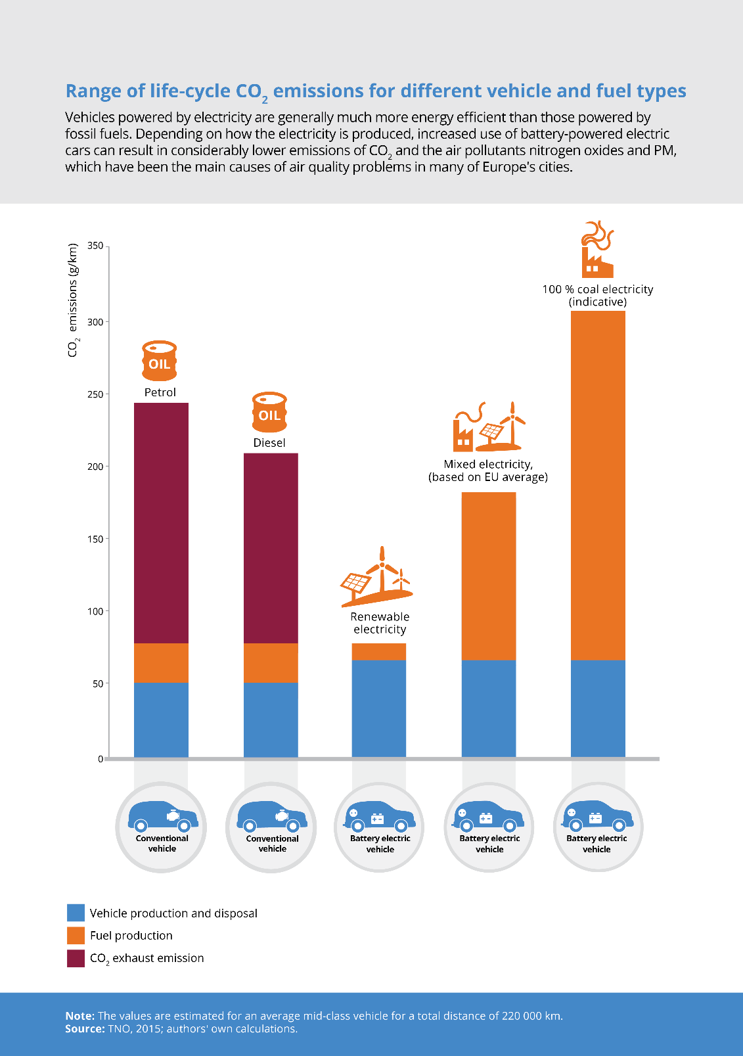

1. If you drive a conventional diesel vehicle, what are your total CO2 emissions in g/km.

220g/km___________________(1 mark)

1. If you drive conventional petrol vehicle, where do most of your CO2 emissions come from?   
   Exhaust __________________________________________(1 mark)
2. Your friend looked at the graphic above and said “obviously electric cars are worse for the environment. Look at the last column!”. Are they are correct? Use values from the graphic to support your answer.  
   They are not correct (1 mark)

They are only looking at one of the columns (1 mark)

They need to consider where the energy comes from (1 mark)

You’re your energy comes from renewable electricity then it is better for the environment (or similar) (1 mark)

1. Give one reason for the difference in emissions between conventional and electric vehicles *vehicle production and disposal*.

Electric cars require more materials to be made (or similar) (1 mark)

Use both the graphic and the knowledge you gained from writing your brochure to answer the last question.

1. What type of car, electric or conventional, would you purchase for yourself? Provide at least 3 reasons for your answer.   
   Type of car (1 mark)

3 reasons (1 mark each)